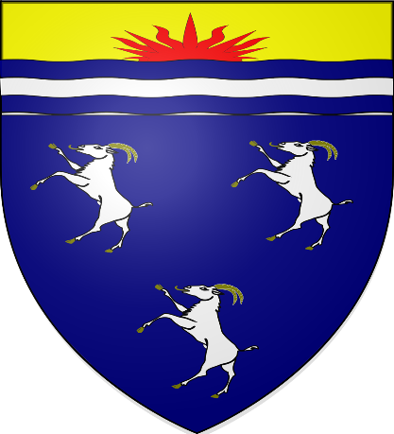

Dolgellau Bio- Diversity Report 2023/24

Environment (Wales) Act 2016 Part 1 – Section 6
The Biodiversity and Resilience of Ecosystems Duty Report 2023/4
Dolgellau Town Council
Introduction and Context
Dolgellau Town Council provides a range of services to its local community which have an impact on
biodiversity.
These include:
• The Responsibility for a number of green spaces including a recreation ground (through the Marian Trustees), FFynnon Fair Woodland, Community Garden (run by volunteers)
• Organising planters and floral displays in the town centre (councillor).
• Funding – Provision for funding is in the precept of the Town Council’s area.
We promote sustainability and biodiversity by pursuing sustainability goals and sustainable practices whenever possible.
We serve approximately 3000 residents. The precept for 2023-24 is £88125.00
Action Report
Action carried out |  | Monitored By
Embed biodiversity into  decision making and  procurement | Reflected the commitment to  biodiversity and natural areas by enhancing Biodiversity in the community areas managed by the Town Council and committing to take into account these considerations when considering planning applications and other  associated matters, such as footpaths diversion orders and neighbourhood services matters.  Developing  adaptation & mitigation responses to the impacts of climate change | Through feedback  from Council  members and  residents.  Numbers of people  taking part in activities (activities other than walking) diversity and protect it from interference(fly tipping unauthorised felling if trees).

Raise awareness of  biodiversity & its  importance | Where possible encourage the public to consider the biodiversity of the natural surroundings  Raise awareness of biodiversity & its importance and contribute to public information schemes and advertising.  To provide bi lingual information boards at the entrances informing the public of the biodiversity and its protection in the woodland setting. Post details of the actions we have taken to help biodiversity on our website and social media platforms. | Through feedback from Council members and residents.  Numbers of people taking part in activities
Safeguard principal species and habitats | This is reflected in the Council’s commitment to undertaking essential grounds works at appropriate times of year and with due consideration for the wildlife and plant-life populations. Installation of bat boxes and bird boxes supplied by Snowdonia National Park | Ensured no negative impacts on protected species.  Records of any sites or species safeguarded.
Restore & create habitats and resilient ecological networks | In conjunction with Snowdonia National Park Dolgellau Town Council has delivered and will continue to deliver tree planting creating diversity in species and size of trees in our woodland, which will become a haven for wildlife.  In the Town Square  Plant flower beds and planters with native pollinator friendly flowers and shrubs.  In the wildlife garden a range of pollinator friendly flowers | Area of habitat has increased.
Identify Species | Through a suitable agency (National Resources Wales) carry out a species survey to obtain a view of what is living in the areas that are controlled by the council  This will enable us to plan and manage the area to suit the wildlife present in our woodland | Increase suitable habitat and increase what may be endangered species

If this policy is accepted the implications to the council would be
Expenditure on a species survey (currently awaiting a price from NRW) bird boxes, bat boxes, bug hotels.
Possible restrictions on work to the woodland (bats and endangered species)
Need to encourage and supervise a greater number of volunteers in order for work to be carried out.
Realisation that we may create a beautiful habitat full of bugs, birds, bats and lots of unspeakable creepy crawlies

-

